SPSPM’s

**SINHGAD INSTITUTE OF BUSINESS MANAGEMENT**

**KAMLAPUR**

**A**

**PROJECT REPORT**

**ON**

“ANIMAL PLANET”

Submitted to

“SOLAPUR UNIVERSITY, SOLAPUR”

For the fulfillment of the requirement for the award of

MASTER OF COMPUTER APPLICATIONS

(SEM-III)

Submitted by

**Mr. Saddamhusen .b.Mujawar**

**Mr.Satyam .s .Pore**

Under the guidance of

**Prof. S .V. Kodad**

**Prof. R .N .Navale**

**. Year-2012-13**

**DECLARATION**

I undersigned that hereby declared that the project of the HTML Entitled **“ANIMAL PLANET”** written and submitted by under work during academic year **2012-13**.

This project or part of it has not submitted previously for any other degree or ant other purpose**.**

Date:

Place: Kamlapur

Roll No. Name of the student Signature

34 Saddamhusen Bashir Mujawar

46 Satyam Sadanand Pore

**ACKNOWLEDGEMENT**

**Thanks,**

I would like to convey my sincere thanks & my deep sense of Gratitude to,

Dr. V.S.Mangnale. (Director)

Prof. R.V.Patil . (H.O.D.)

For giving me an opportunity to work & showing confidence to access the facilities .

I also thankful to M.C.A. staff for giving confidence & inspiration.

Roll No. Name of the student Signature

34 Saddamhusen Bashir Mujawar

46 Satyam Sadanand Pore

**INDEX**

|  |  |  |
| --- | --- | --- |
| **Sr.No** | **Particulars** | **Page No.** |
| 1. | Introduction To HTML |  |
| 2. | Introduction To system |  |
| 3. | Scope & Objective of system |  |
| 4. | System Analysis  * Site Map |  |
| 5. | System Design |  |
| 6. | User Requirement |  |
| 7. | Coding |  |
| 8. | Conclusion |  |
| 9. | Bibliography |  |

**HTML stands for Hyper Text Markup Language.**

**Hypertext is ordinary text that has been dressed up with extra features such as formatting images, multimedia and links to other documents.**

**Markup is the process of taking ordinary text and adding extra symbols such as editor proof reading symbols are type markup. Each of the symbols used for markup in HTML is command that tell the browser how to display the text.**

**HTML is a computer language, related to computer programming languages like BASIC, c and Pascal. HTML has its own syntax and rules for communication markup languages are special type of computer languages, they are connected with only parts of document according to their function. They indicate which part of document is title which is subheading which is author name and so on HTML is not relay a programming, but it a markup language.**

* **HTML Features**

**The internet is international network of computer that exchange information with each other. The World Wide Web (WWW) is a vast interconnected library of information art and commerce. The web consists of several web pages. HTML is used to build web pages. Once web page is built it can be published on internet. Publishing means transferring web page to a server so that people all over the world will be able to read it. There is a huge variety of web pages for e.g. we have personnel home pages, business home pages directories (list of web pages), search engines and artist projects. It is universal language for classifying the function of different section of a document. It defines different parts of your page. You can indicate which par is title, which part is head, which part is address, which part should be emphasized and which part should include an image and so on. HTML specifies part of your document is that a browser can display it correctly.**

* **Advantage of HTML**
  + **For creating HTML document what you need is only edited by text editor no special software is required. E.g. In windows you can use Notepad for typing and editing a HTML pages.**
  + **No special software is required.**
  + **HTML contains powerful formatting facility.**
  + **Learning html is similar than any other programming language.**
  + **It is very simple than other language.**
  + **HTML will not cost you anything for its use, there are no expansive licenses to buy or no upgrade to purchase.**
  + **HTML cerates on any hardware platform**
* **Limitations of HTML**
* **HTML does not offer programming language feature and capability.**
* **It can not be used to display even a date.**
* **The interactive web page can not be built in HTML.**
* **Html is no a programming language in true sense.**
* **Any hyperlink is provided in HTML but for that we need a trip to server at each step.**
* **HTML can not provide any security for the code.**
* **Classification (Home link)-**

**Animals are classified in a variety of ways. This helps scientists to study the relationships in animal groups and to see the whole animal family tree as it has developed through time. The study of animal classification is called taxonomy.**

**a) Molluska-**

**This link provides information about Molluska. A mollusk is another name for a shellfish. Shellfish are not all fish and many of them live on land. Not all of them have shells. They are not fish, although many of them live in the water.**

**b) Reptiles-**

**This link provides information about Reptiles. Reptiles are a class of the chordate phylum. They have scaly skin and feet with claws on their toes. Both the babies and the adults breathe through lungs. They have a breastbone called a sternum to protect the heart and lungs. The female's eggs are fertilized in her body by the male. The eggs are laid in a shell that has a leathery covering to protect it in the wilds. The common reptiles are snakes, turtles, lizards alligators and crocodiles.**

* **Snakes**
* **Lizzards**
* **Turtles**
* **Alligators and Crocodiles**

**c) Flatworm-**

**Flatworms are the simplest of the worm groups. There are about 20,000 species in this group. They are found many places and can be free living or parasitic. A parasite lives off of another living thing called a host and can be harmful. One of the best known flatworms is the tapeworm. The tapeworm can get into a person's digestive tract and grow to enormous lengths. The tapeworm then eats off the host and is dangerous to the host as it grows and consumes more of the host and its food.**

**d) Starfish-**

**Starfish belong to a group or phylum of animals called echinoderms. This means "spiny skinned" in Greek. Echinoderms live in salt water only. They generally have five arms and dwell at the bottom of oceans' levels. There are around 6000 species of echinoderms. The starfish, sea urchin, sea cucumber and sand dollar are some good examples.**

**e) Birds-**

**Birds are a class of the chordates or vertebrate phylum. They are similar to other chordates in that they have a backbone. They are unique in the fact that they are covered with feathers and fly.**

* + **owl**
  + **Parrot**
  + **Peacock**
  + **Eagle**
  + **Duck**

**f) Roundworms-**

**Roundworms are a member of the nemathelminths phylum or group of animals. The hookworm, pinworm and trichinella are part of this group. They are more advanced than flatworms but less advanced than earthworms. They have thin round bodies, with none of the pieces or segments that earthworms have in their bodies.**

**g) Chordates-**

**Chordates are animals with backbones. Animals with backbones are the most highly evolved groups of animals, the most complex and complicated. They have interior skeletons and have bilateral symmetry. They have more advanced brains.**

**h) Mammal-**

**Mammals are a class in the chordate phylum. Mammals are like other chordates in that they have backbones. Mammals have several distinct characteristics.**

**i)Earthworm-**

**Earthworms are the most highly developed worms. They are divided into segments or parts. They are found in salt and fresh water as well as in the soil. Earthworms are helpful to man as bait for fishing and more importantly, because they loosen the soil for roots to grow.**

**j)Fish-**

**The fish are the class of chordates that live completely in water. Their bodies have three main parts; the head, the trunk of the body and the tail. Their bodies are covered in scales and also a protective slime. They are important as a food source for animals.**

**k)Sponge-**

**There are about 5,000 species of sponges found throughout the world. Most sponges are found in oceans, although some groups are found in fresh waters such as lakes. They were the first group of animals that has specialized cells to do special jobs. However, the cells are not so advanced as to form tissues. Sponges live singly or in colonies.**

**l)Insect-**

**This link provides information about insect group.**

* **Ants**
* **Spider**

**m)Amphibian-**

**The amphibian, because it must be moist, sometimes hides out in the summer as if hibernating. This is called estivation. It also buries itself in the mud during the winter and hibernates to prevent it from freezing as it is cold blooded.**

**n)Functions of animal**

* **Scope**

**As biologists of plants & animals are widely expanded but compared to plants animals scope in biology is widely distribute in the environment. There is billion types of animals & these animals need to be classification for faster information about their life**

**So the scope of classification is designed by considering the some levels of organization**

**Of animals’ organisms, those are as follows:**

**Molecular level**

**Cellular level**

**Tissue level**

**Dorgan level**

**Organism level**

**Community level**

**Ecosystem level**

**As the scope of classification is very huge then the classification of animals is structured by considering vertebrates animals (which have a backbone) and invertebrates animals (which lacking a backbone).**

**If we want to study the classification in clear manner. We must be consider the scope of it. In our whole project we have efficiently discussed the scope and describe the clear information of classified animals as their scope.**

* **Objectives**

**Animals are living organisms. In the world, there are number of animals & each has different identity from each other. So the biologists distinguishes that animals are classified into different groups by considering the following objectives:**

* **To identify characteristics of each animal**
* **To study the structure of each animal**
* **To distinguish animals from each other**
* **To understand life style & differences between living criteria of animals, which belongs to different classes**
* **To developing the criteria of biology, for greater classificationof animals.**
* **To minimize complexity while research for new ones.**
* **To motivate other biologist which have interest in develop new technology in bioinformatics & its study.**
* **To understand & study different systems of various animals like Ecosystem, Production system, Digestive system, Aspiration system etc.**

**We have not seen such kind of any website who gave the core information about the Animal . Only little number of websites are available to providing the partial information. I have tried to overcome this problem.**

* **Requirement Analysis**

**To create any particular website the analysis is necessary. It will give the information domain for the software with functional behavior, performance etc. An organization creates the website to display their information but there is no such information. To solve this problem we should find out the existing problems and try to solve it.**

* **Software Performance**

**Major places such a thing which is near to the heart of human beings. Before developing the actual system some prototypes should made which is the abstract representation of the whole system. They give the exact idea that how the system should be.**

**It must be:-**

* **User friendly.**
* **Working as a human activity.**
* **Readable and easy to understand.**
* **Cost suitable and satisfied.**
* **Maintain a quality and time consuming.**
* **Feasibility Study**

**It is the system feasibility that depends on operation, techniques and Economy. Operational feasibility gives the efficiency of a system. If the system is user friendly it doesn’t require an expert or special training. In this case the user doesn’t require system knowledge.**

* **Technical Feasibility**

**Technical feasibility means the system doesn’t require any hardware of software resource. No extra network components are required for the use of the product. The system must work on all machines and all operating systems.**

* **Economic Feasibility**

**Economic Feasibility is the most important aspect in system analysis. The development of system should not be so costly. It should adopt changes easily without paying more for it.**

**HOME**

**About us**

**Spider**

**Ants**

**Insect**

**Mammal**

**Chordate**

**Peacock**

**Birds**

**Turtles**

**Crocodil**e

**MPLLUSKA**

**Flatwarm**

**Feedback form**

**Repitle**

**Starfish**

**Snake**

**Animal function**

**Lizard**

**Photos**

**Amphibian**

**Roundworm**

**Owl**

**Eagle**

**Parrot**

**Duck**

**Fish**

**Earthworm**

**Sponge**

**HOMEPAGE:-**

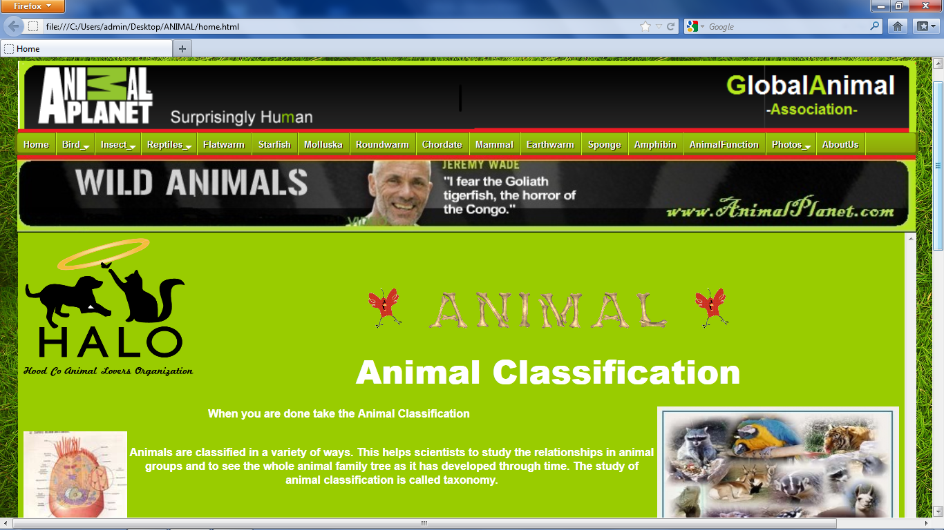

**BIRD:-**

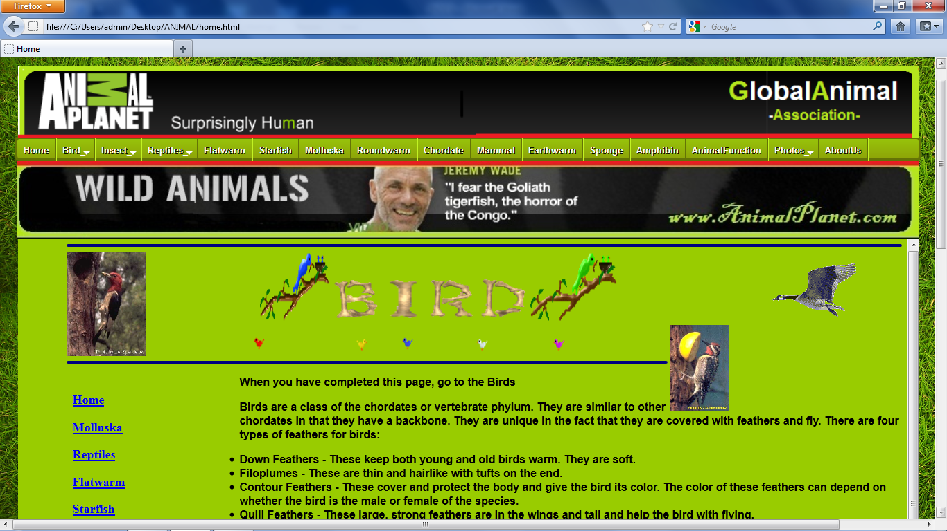

**BIRD OWL:-**

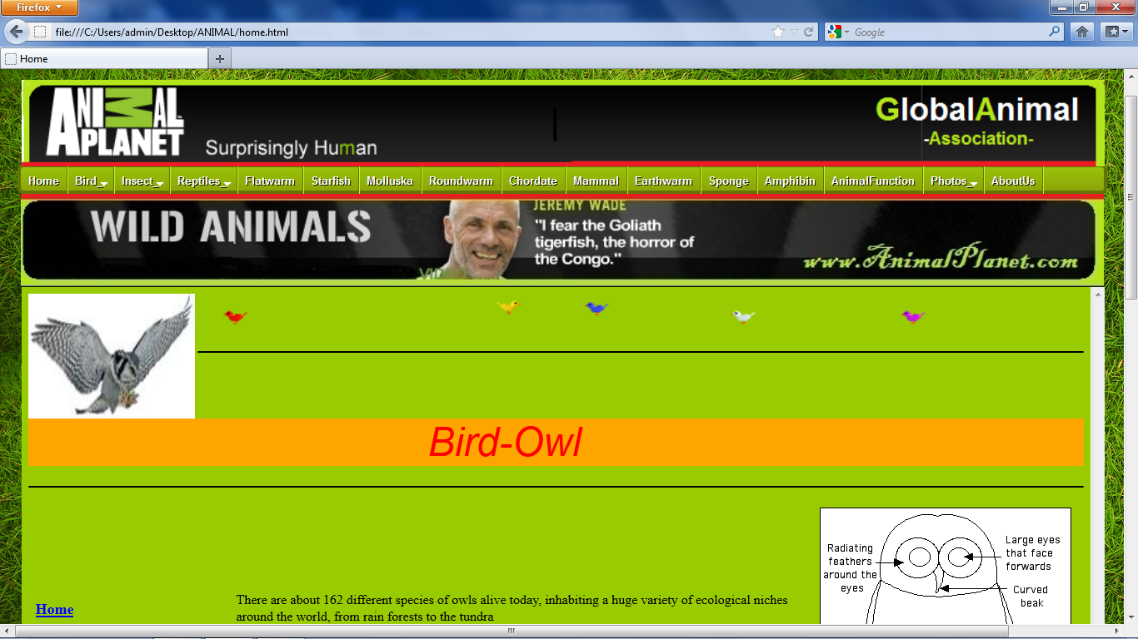

**BIRD PARROT:-**

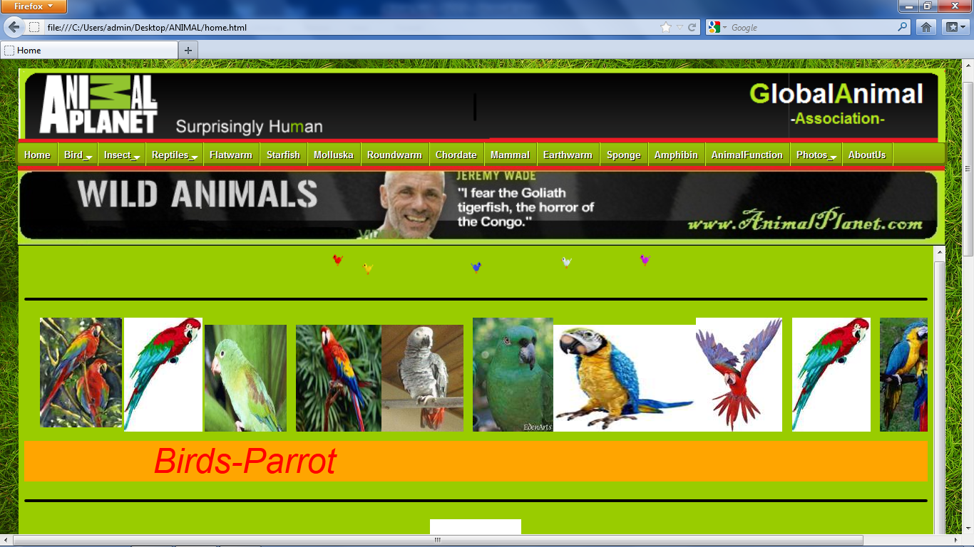

**BIRD PEACOCK:-**

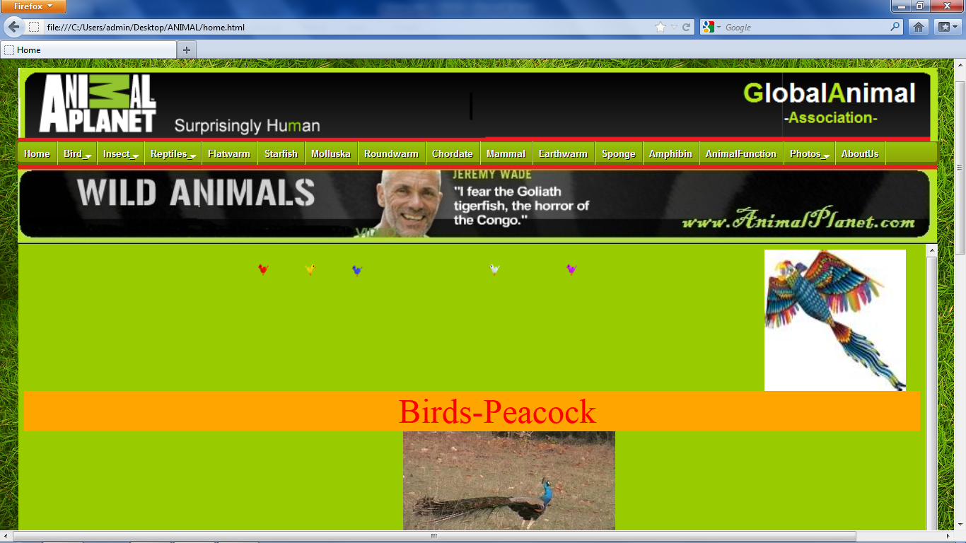

**BIRD EAGLE:-**

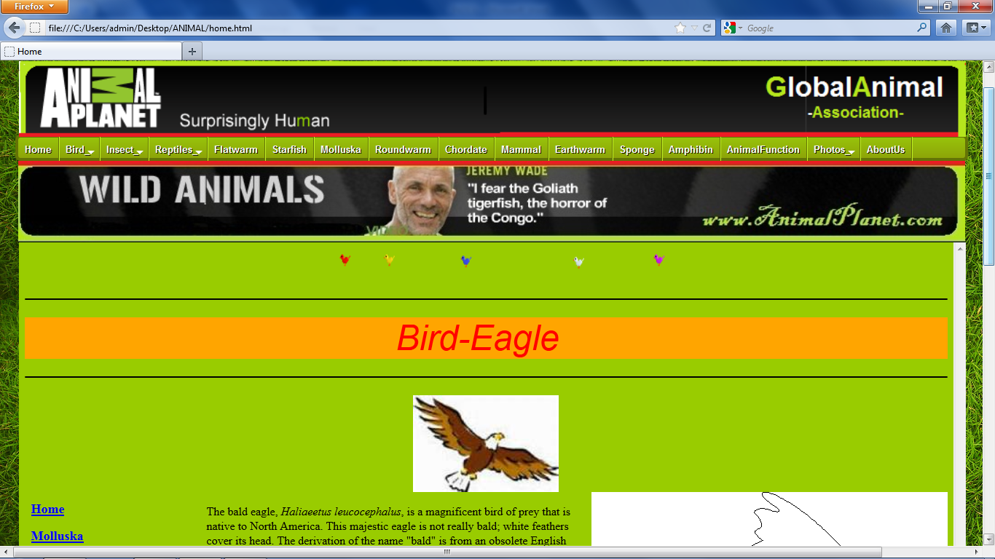

**BIRD DUCK:-**

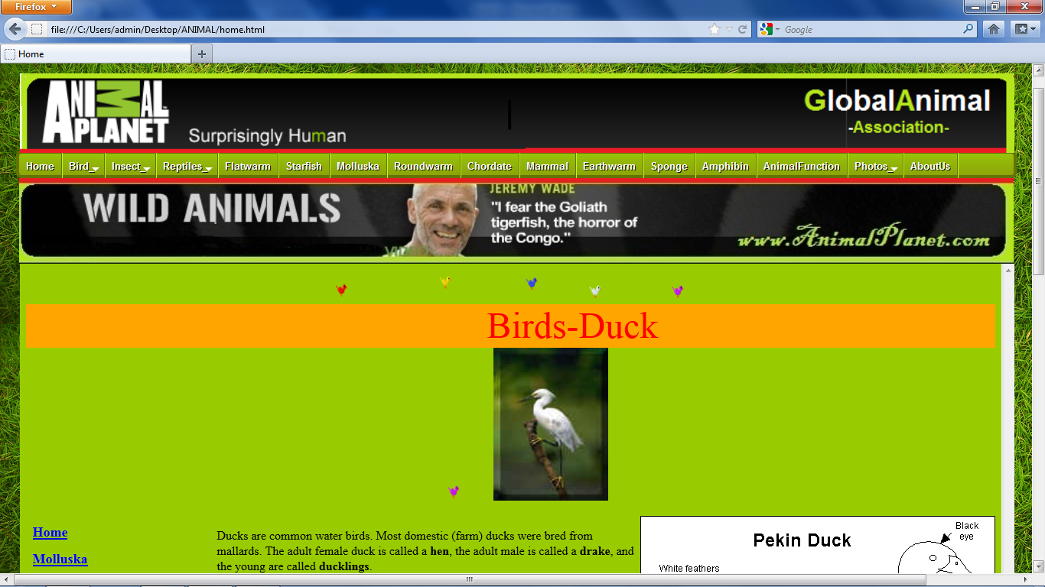

**INSECT:-**

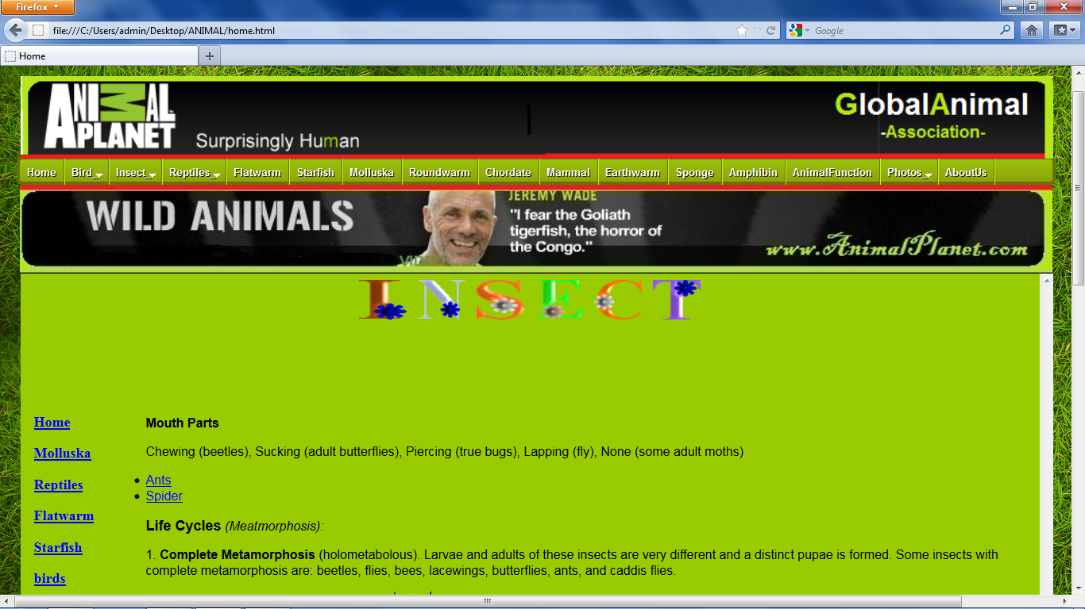

**ANTS:-**

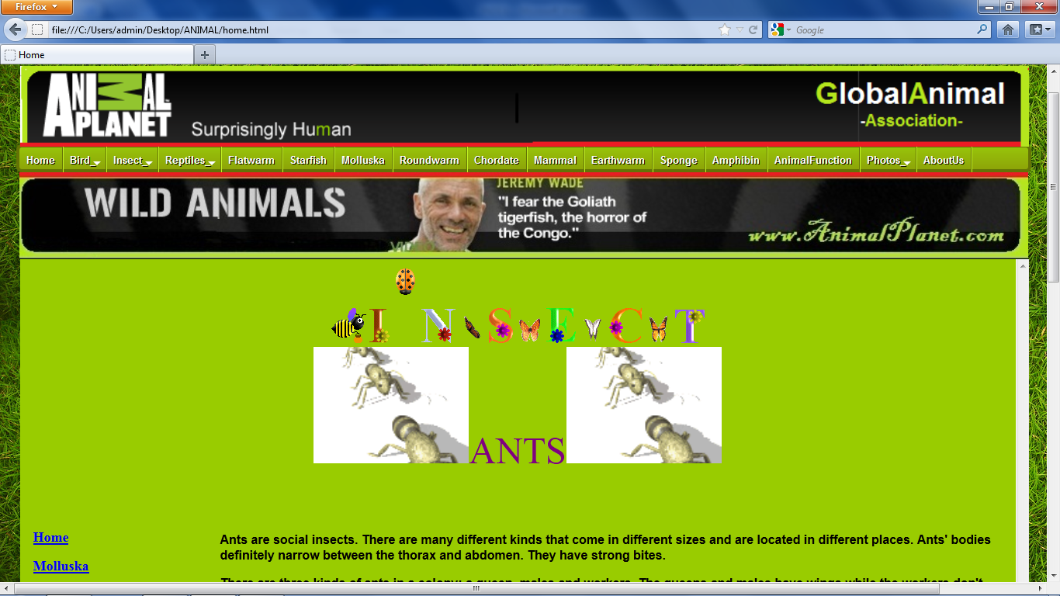

**SPIDERS:-**

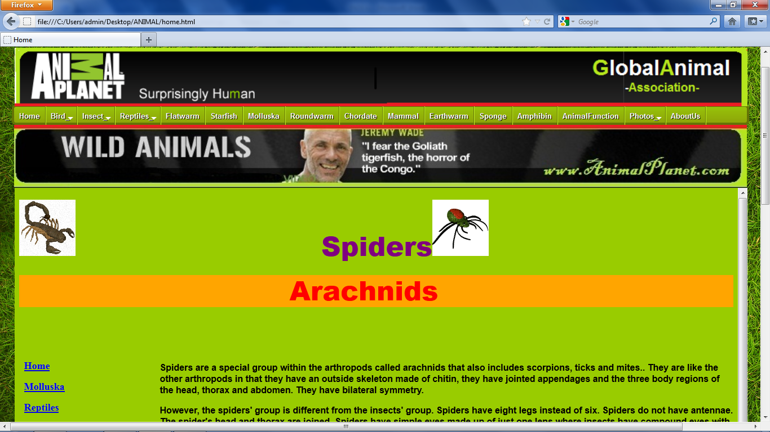

**REPTILE:-**

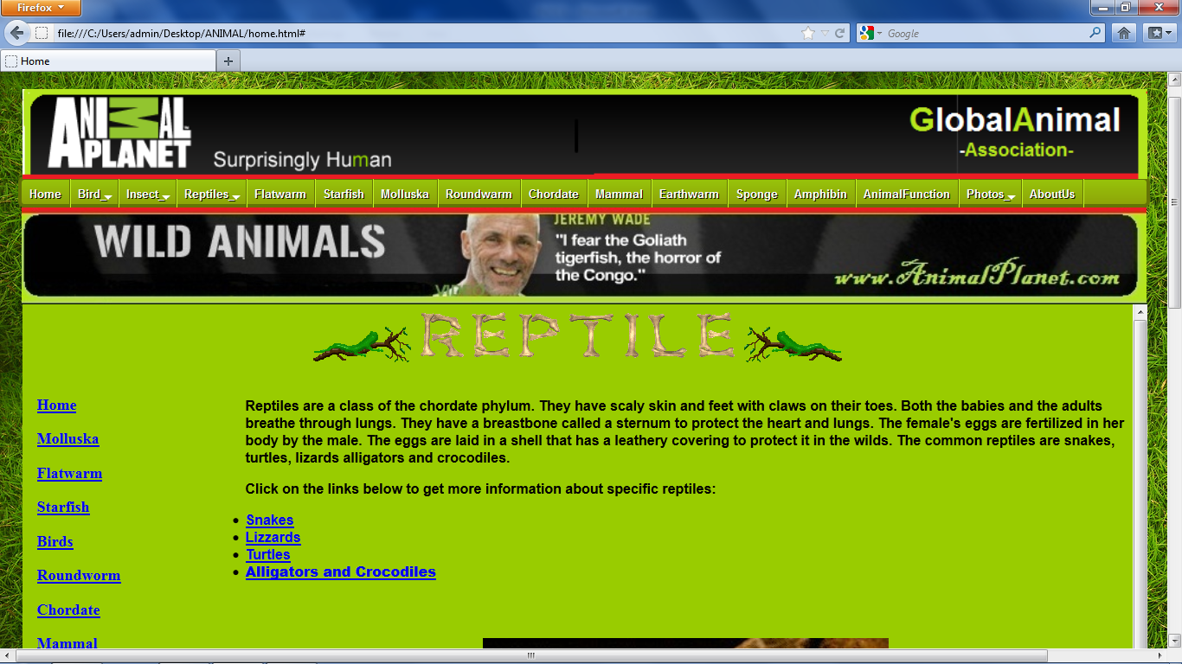

**SNAKES:-**

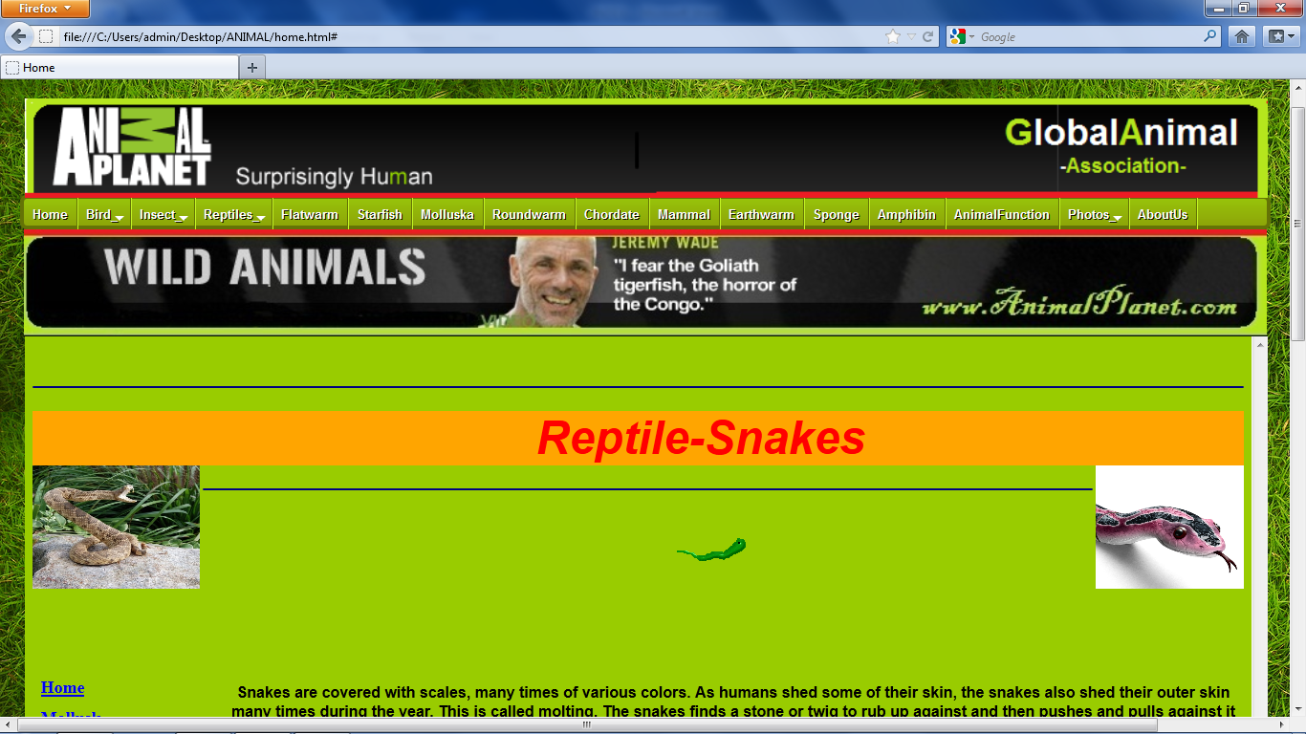

**LIZZARD:-**

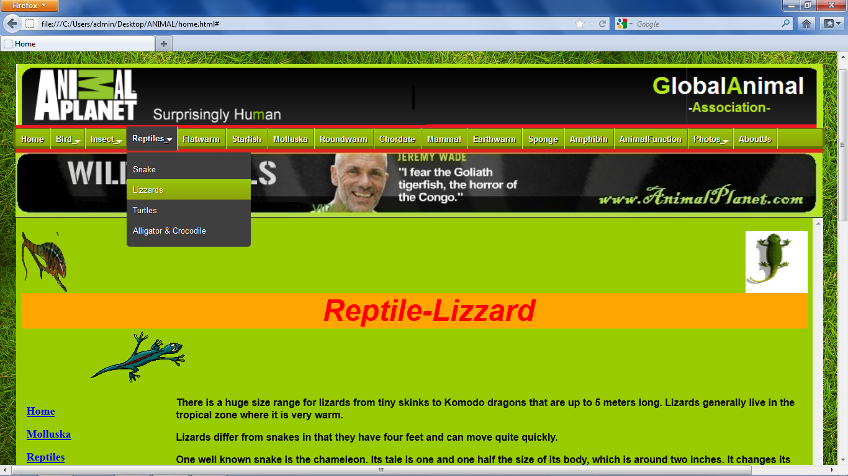

**TURTLES:-**

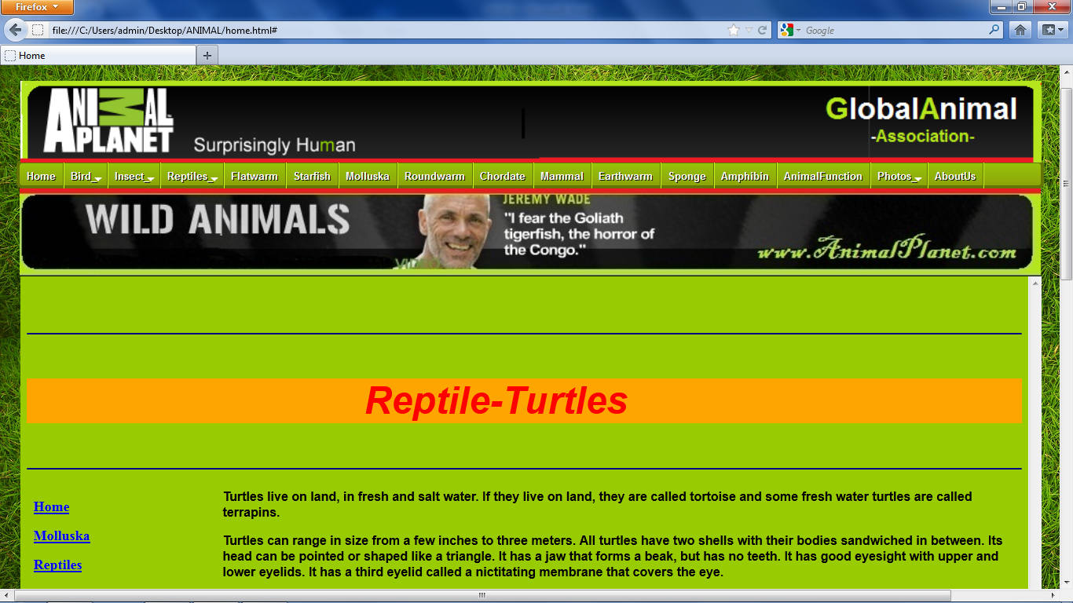

**ALLIGATORS AND CROCODILES:-**

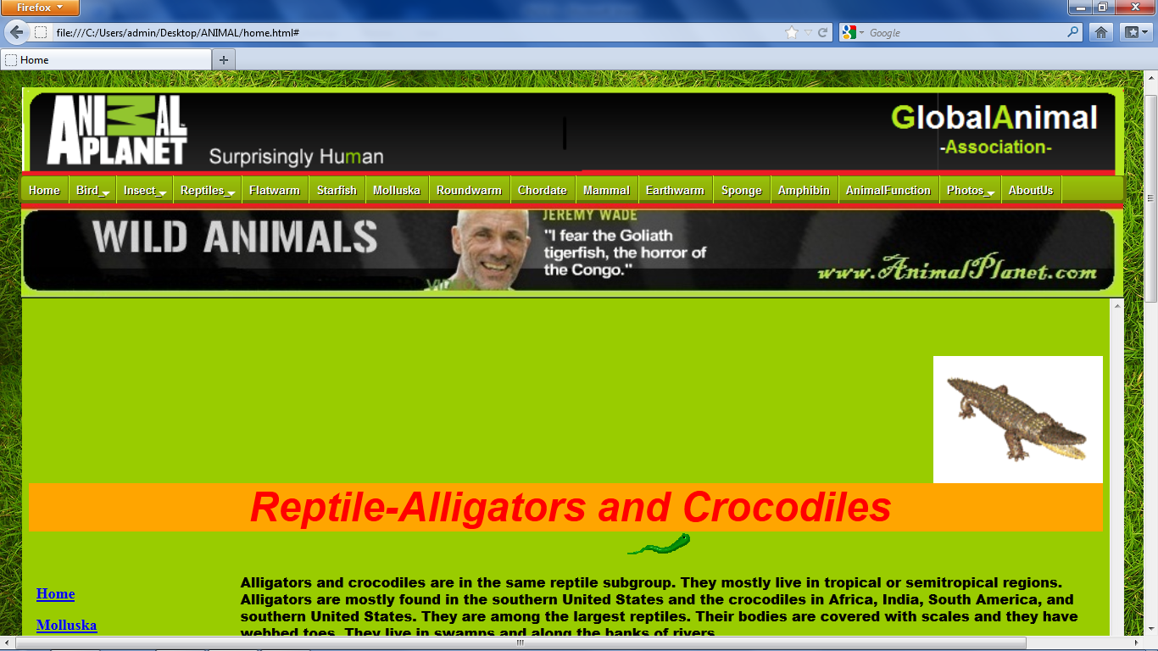

**FLATWARM:-**

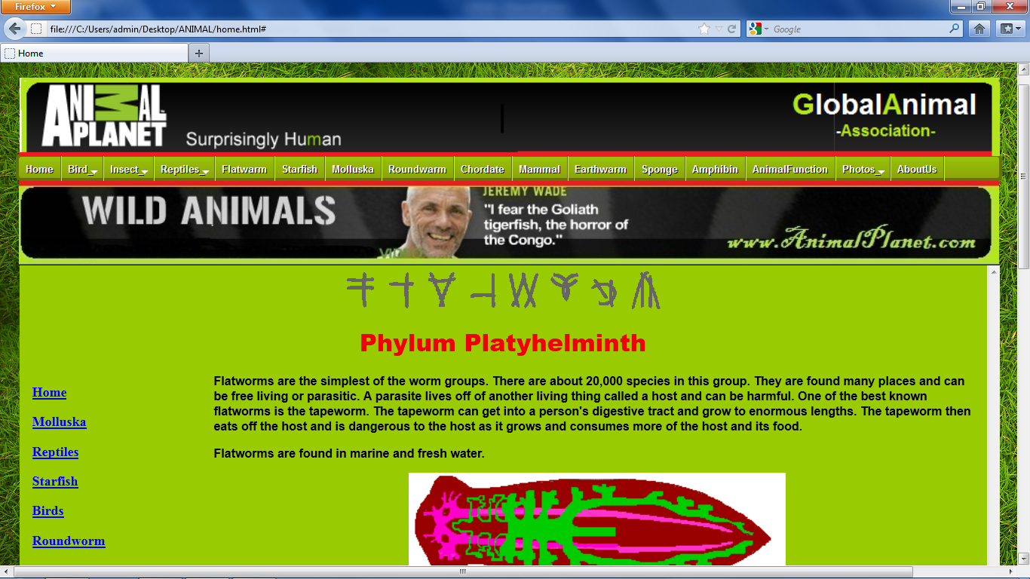

**STARFISH:-**

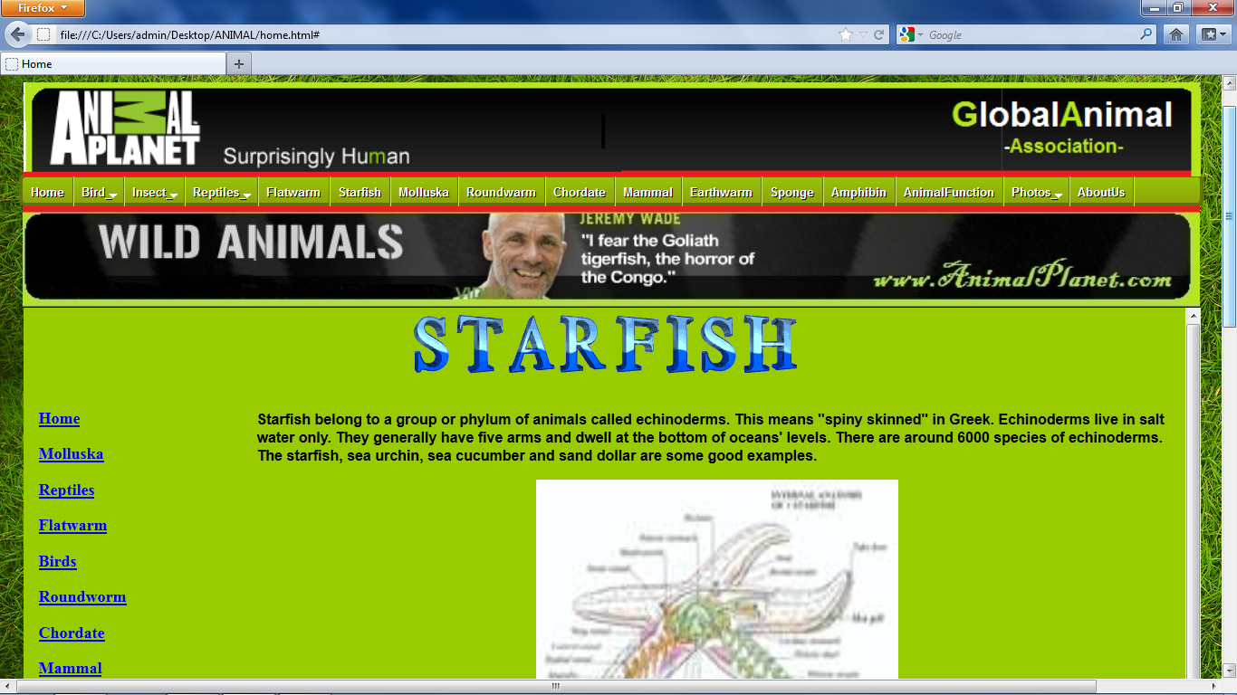

**MOLLUSKA:-**

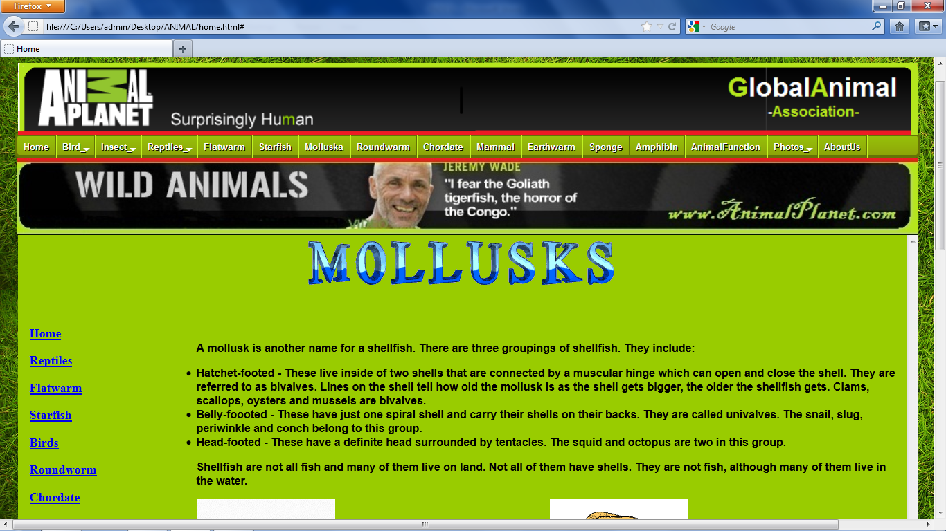

**ROUNDWORM:-**

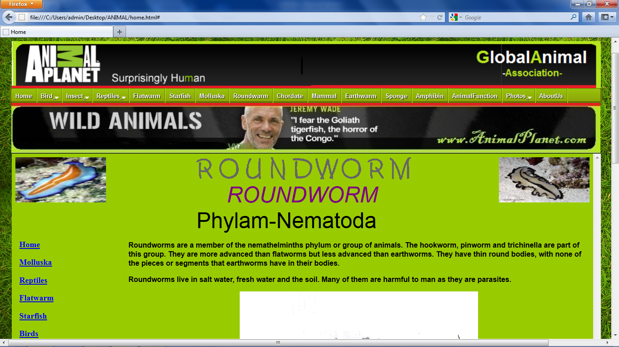

**CHORDATE:-**

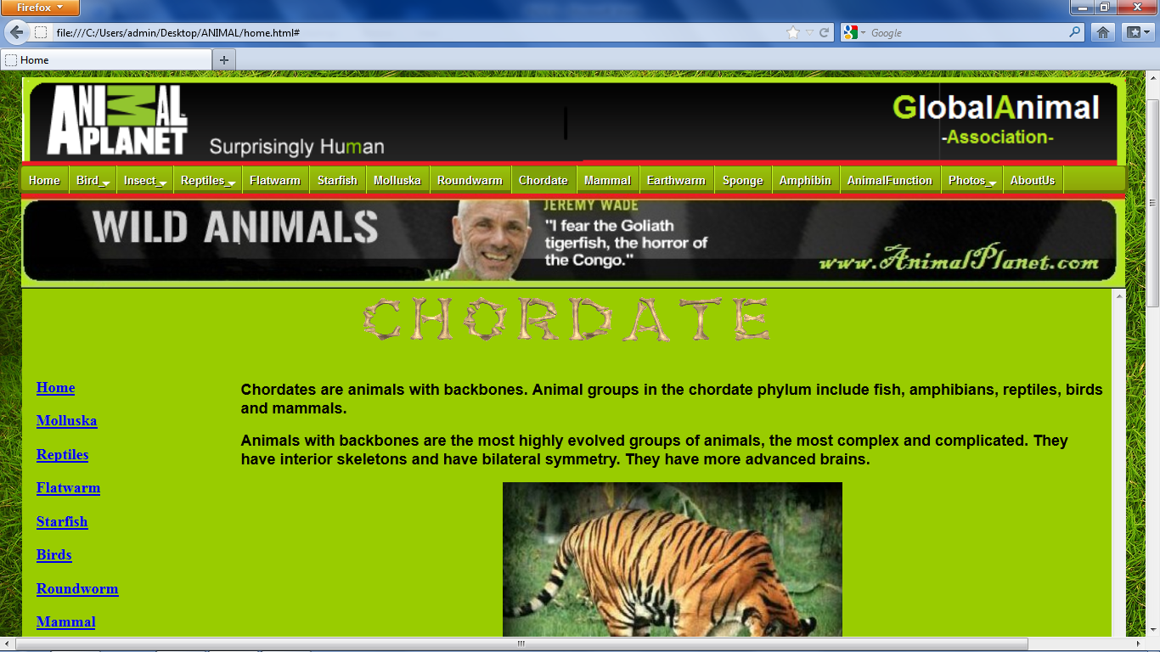

**MAMMAL:-**

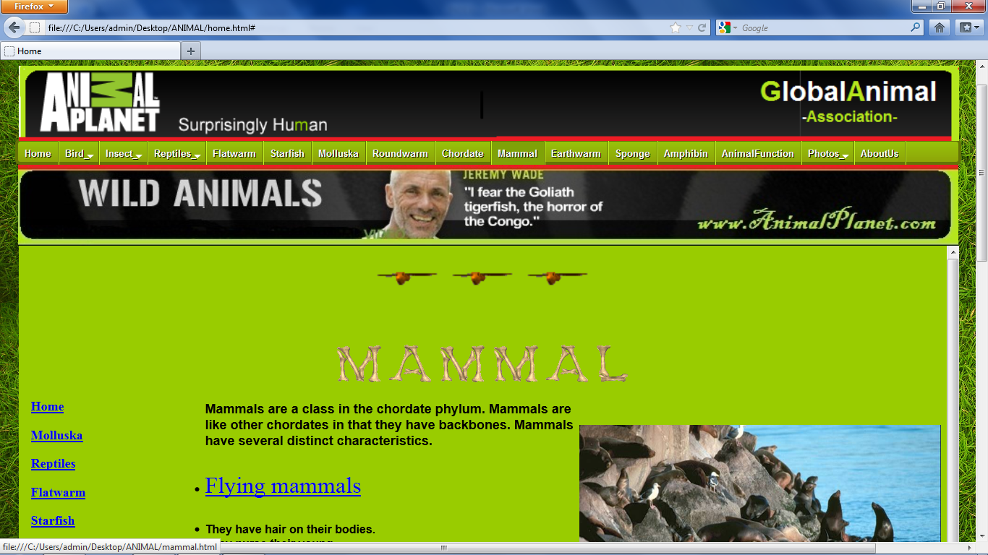

**EARTHWORM:-**

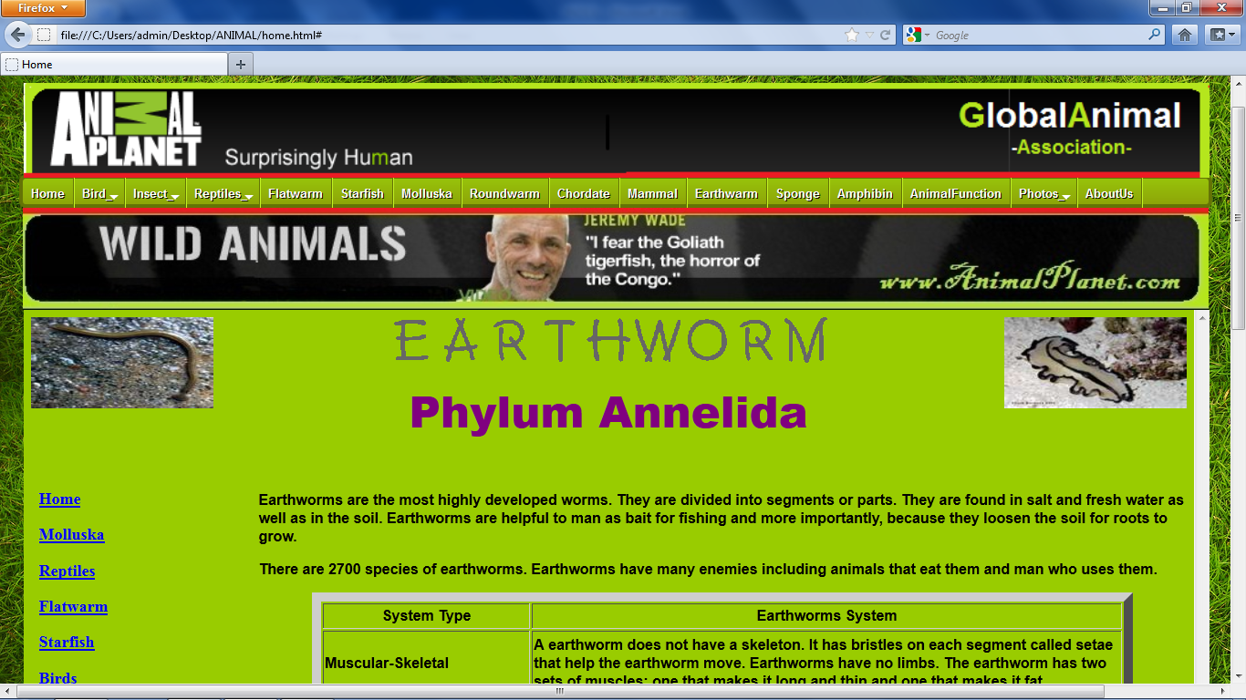

**SPONGES:-**

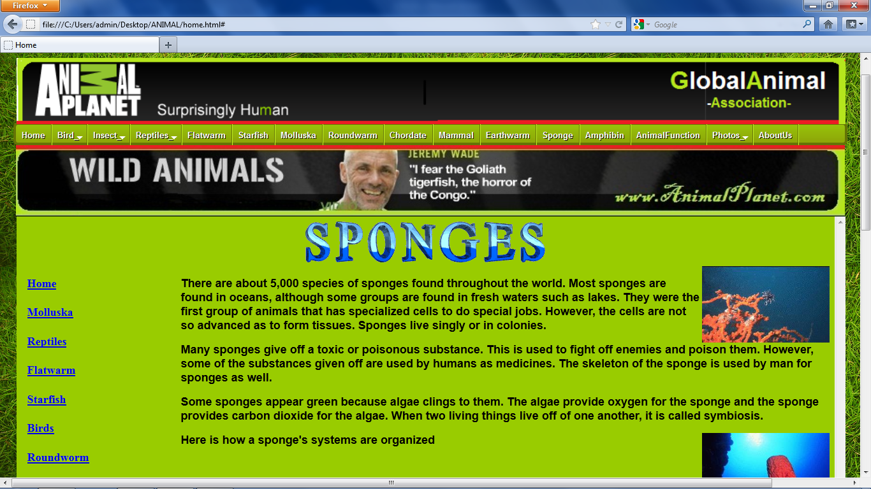

**AMPHIBIAN:-**

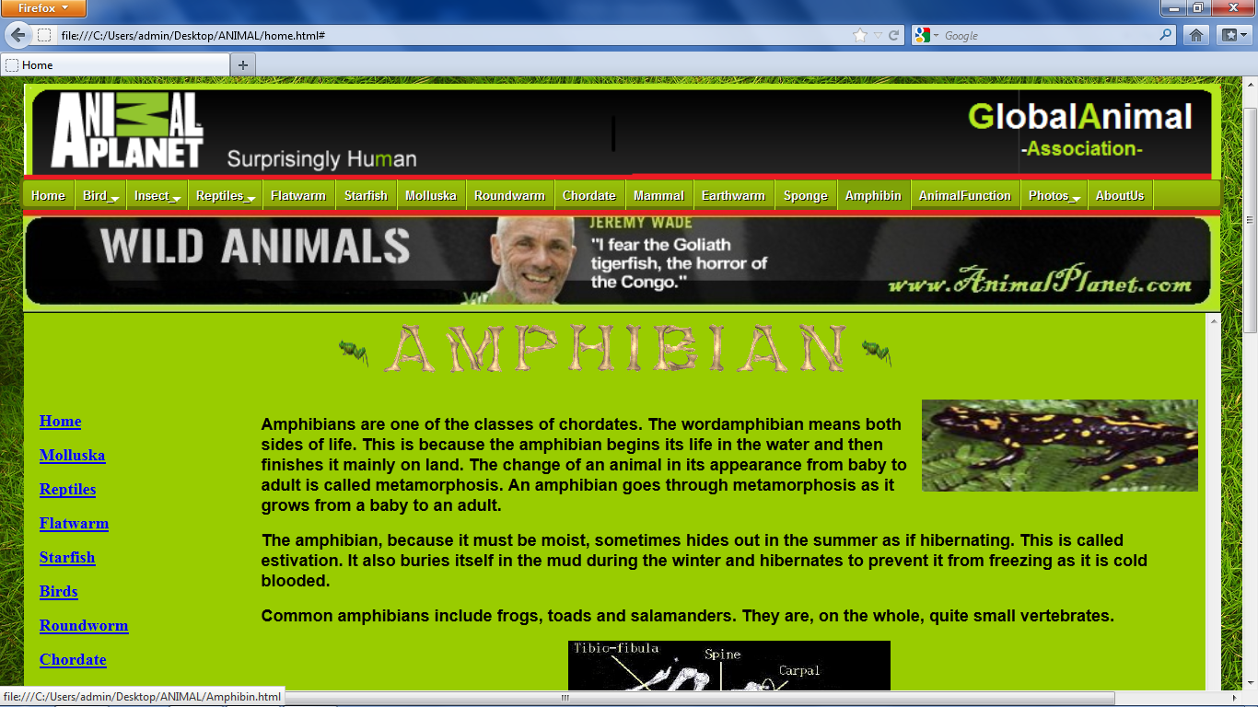

**ANIMAL FUNCTION:-**

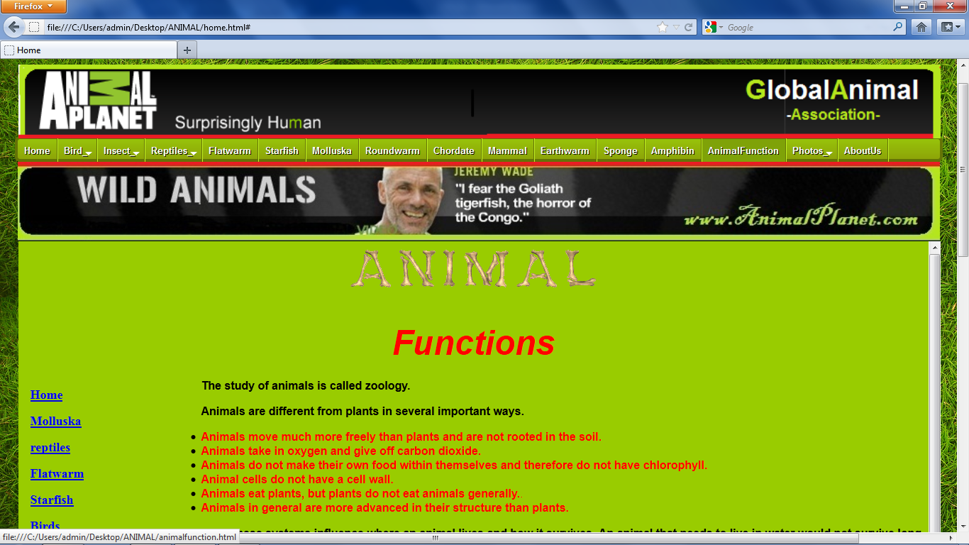

**PHOTOS:-**

**AMPHIBIANS:-**

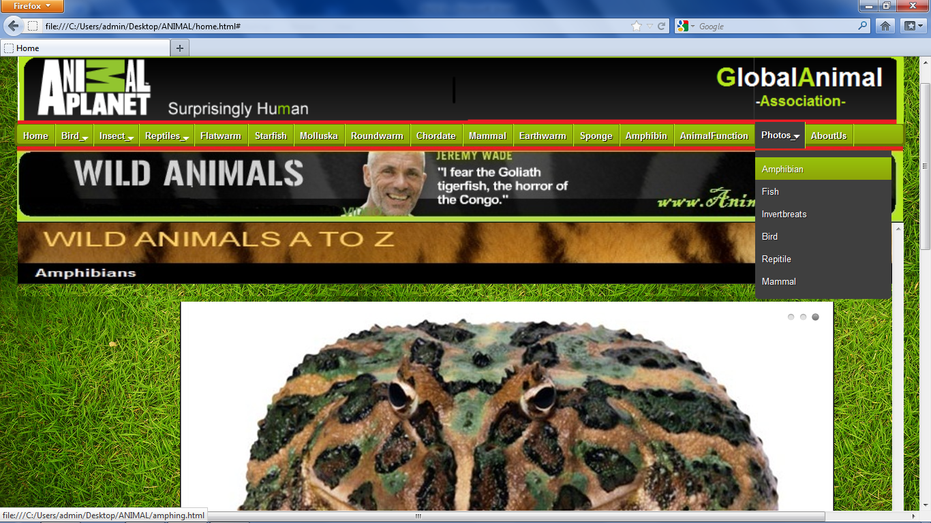

**FISH:-**

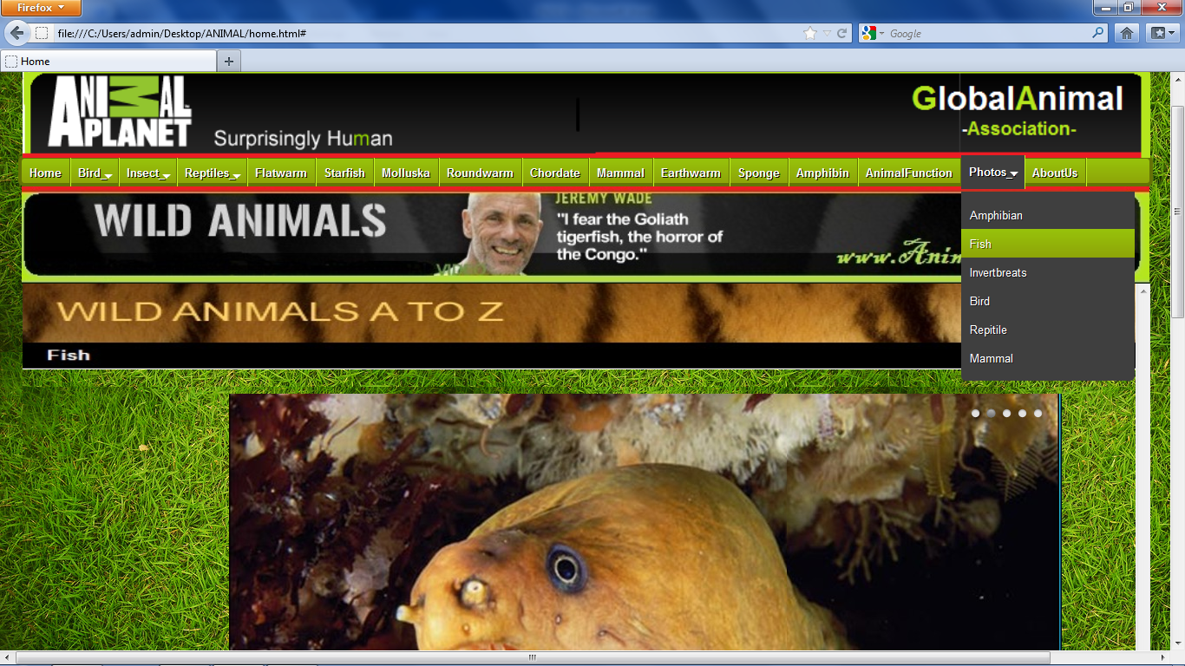

**INVERTBRATES:-**

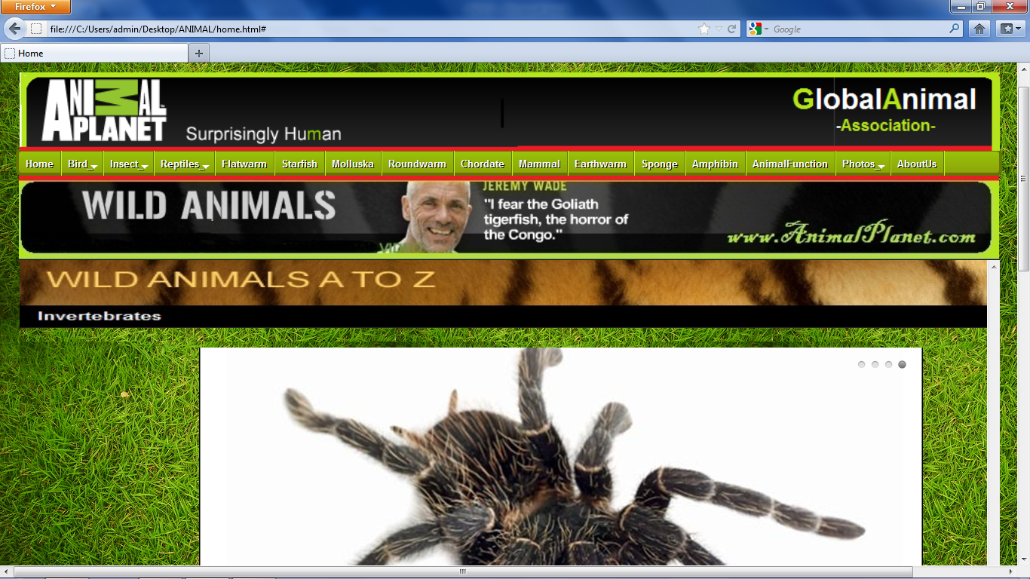

**BIRD:-**

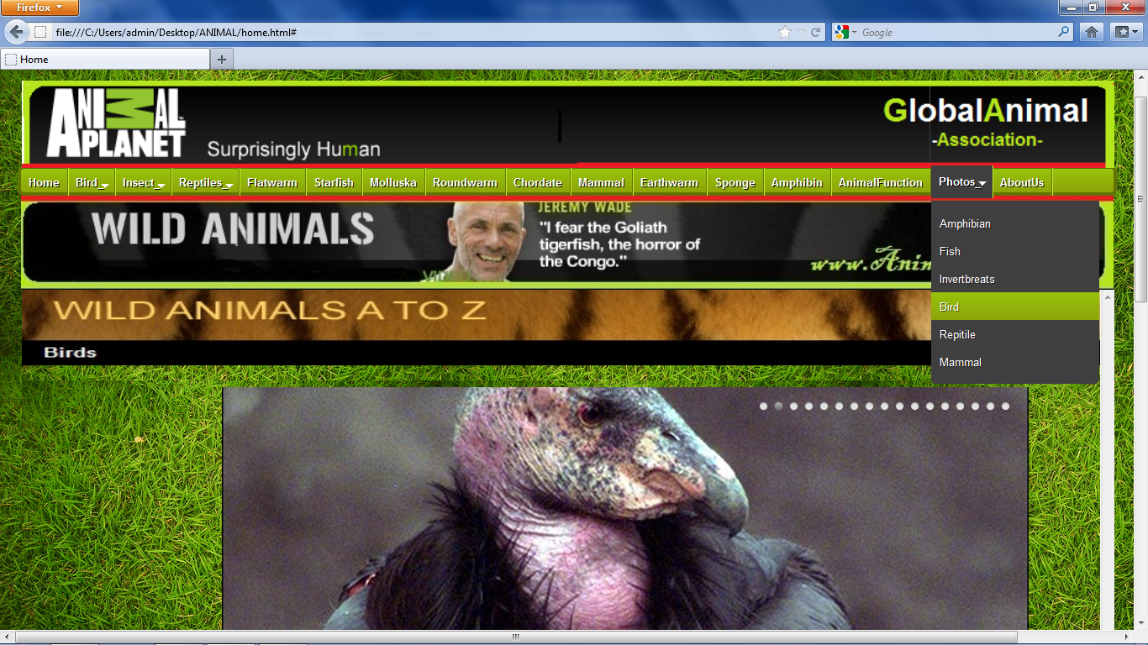

**REPTILES:-**

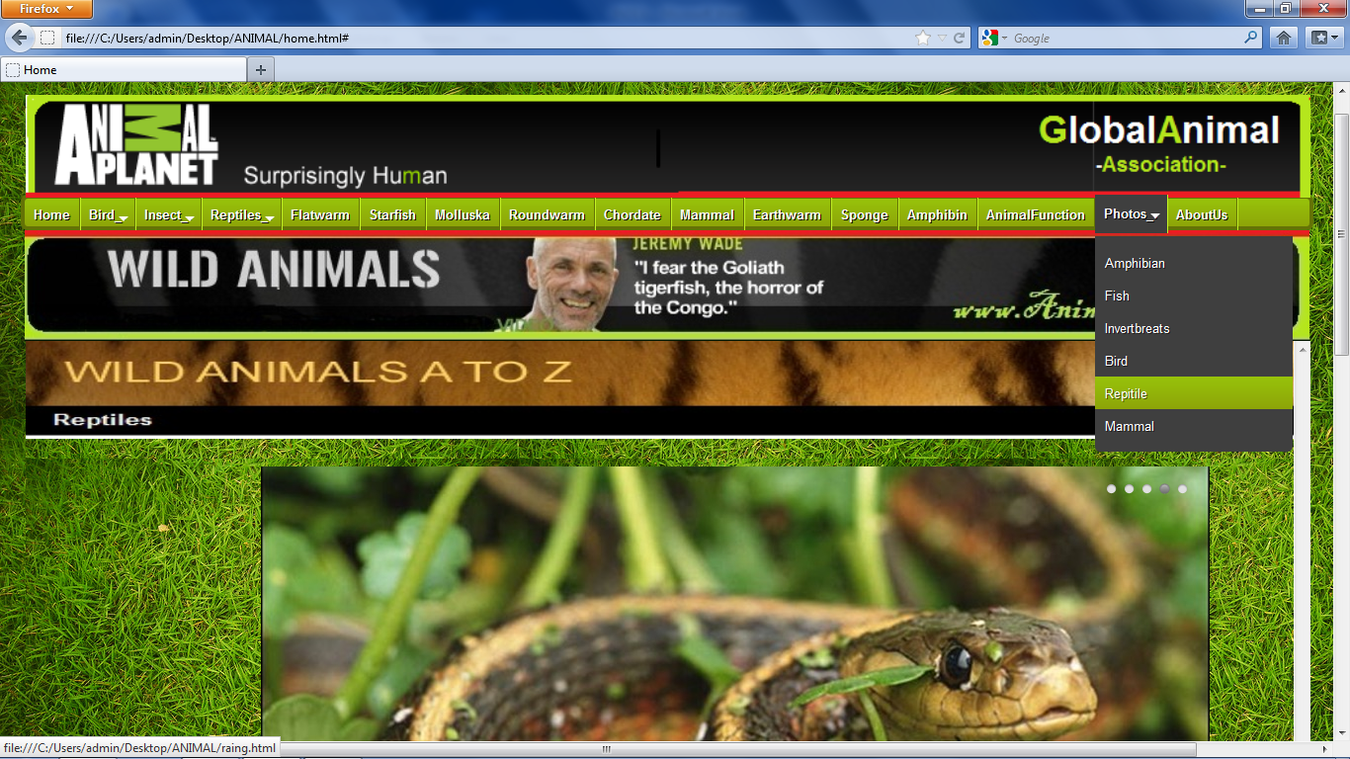

**MAMMALS:-**

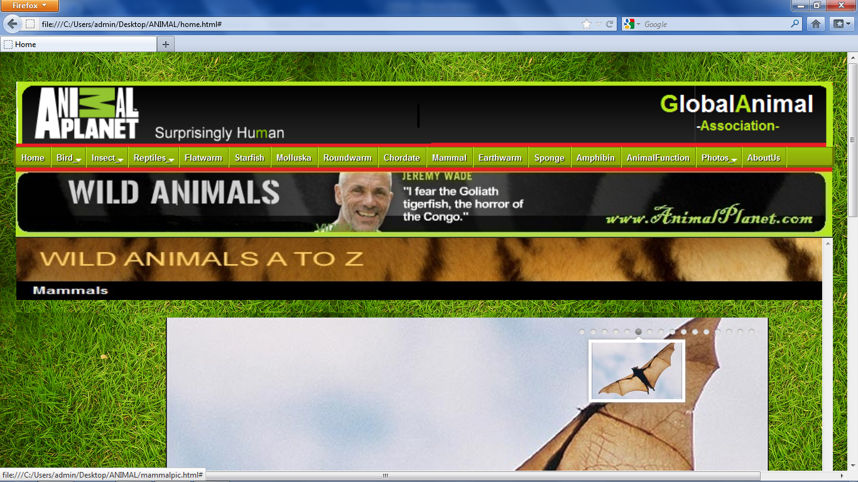

**ABOUT US:-**

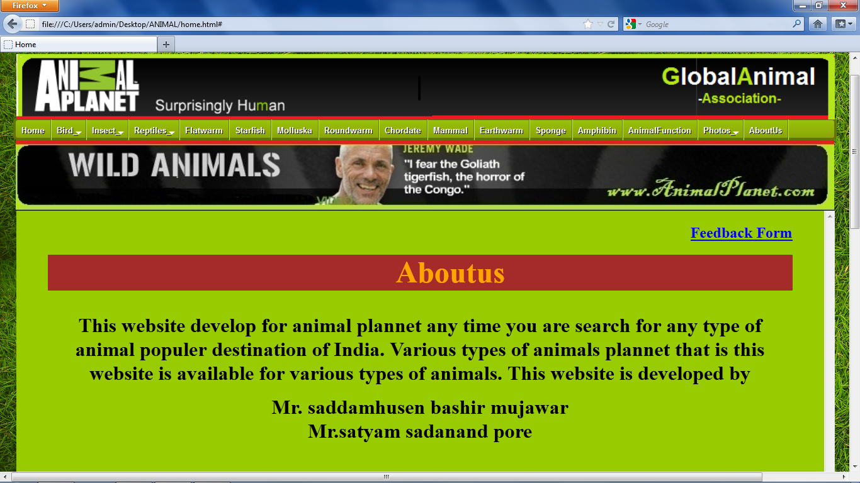

**FEEDBACK:-**

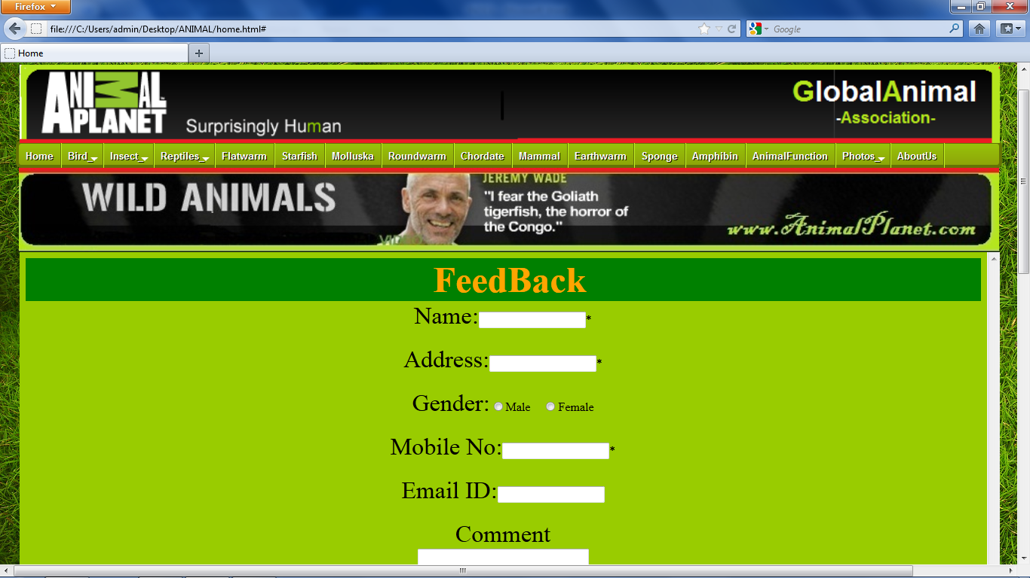

**CODING:-**

**HOMEPAGE:-**

<html>

<head>

<title>Home</title>

<div style="position:relative;left:7px;top:28px;">

<center><iframe src="a.html" width="1440" height="120" scrolling="no" frameborder="0" ></iframe>

</center></div>

<body background="Blog Dinosaur 8.jpg" width="1400" height="2500">

<style type="text/css">

#cssmenu{ height:28px;width:1300px; display:block; padding:0; margin:20px auto; border:4px solid; border-radius:7px; }

#cssmenu > ul {list-style:inside none; padding:0; margin:0;}

#cssmenu > ul > li {list-style:inside none; padding:0; margin:0; float:left; display:block; position:relative;}

#cssmenu > ul > li > a{ outline:none; display:block; position:relative; padding:10px 9px; font:bold 13px/100% arial, Helvetica,Lucida Handwriting; text-align:center; text-decoration:none; text-shadow:1px 1px 0 rgba(0,0,0, 0.9); }

#cssmenu > ul > li:first-child > a{border-radius:6px 0 0 5px;}

#cssmenu > ul > li > a:after{ content:''; position:absolute; border-right:1px solid; top:-1px; bottom:1px; right:-2px; z-index:99; }

#cssmenu ul li.has-sub:hover > a:after{top:0; bottom:0;}

#cssmenu > ul > li.has-sub > a:before{ content:''; position:absolute; top:18px; right:6px; border:5px solid transparent; border-top:5px solid #fff; }

#cssmenu > ul > li.has-sub:hover > a:before{top:19px;}

#cssmenu ul li.has-sub:hover > a{ background:#3f3f3f; border-color:#3f3f3f; padding-bottom:13px; padding-top:13px; top:-4px; z-index:999; }

#cssmenu ul li.has-sub:hover > ul, #cssmenu ul li.has-sub:hover > div{display:block;}

#cssmenu ul li.has-sub > a:hover{background:#3f3f3f; border-color:#3f3f3f;}

#cssmenu ul li > ul, #cssmenu ul li > div{ display:none; width:auto; position:absolute; top:38px; padding:10px 0; background:#3f3f3f; border-radius:0 0 5px 5px; z-index:999; }

#cssmenu ul li > ul{width:200px;}

#cssmenu ul li > ul li{display:block; list-style:inside none; padding:0; margin:0; position:relative;}

#cssmenu ul li > ul li a{ outline:none; display:block; position:relative; margin:0; padding:8px 10px; font:10pt Arial, Helvetica, sans-serif; color:#fff; text-decoration:none; text-shadow:1px 1px 0 rgba(0,0,0, 0.5); }

#cssmenu, #cssmenu > ul > li > ul > li a:hover{ background:#97c20a; background:-moz-linear-gradient(top, #97c20a 0%, #8da408 100%); background:-webkit-gradient(linear, left top, left bottom, color-stop(0%,#97c20a), color-stop(100%,#8da408)); background:-webkit-linear-gradient(top, #97c20a 0%,#8da408 100%); background:-o-linear-gradient(top, #97c20a 0%,#8da408 100%); background:-ms-linear-gradient(top, #97c20a 0%,#8da408 100%); background:linear-gradient(top, #97c20a 0%,#8da408 100%); filter:progid:DXImageTransform.Microsoft.gradient( startColorstr='#97c20a', endColorstr='#8da408',GradientType=0 ); }

#cssmenu{border-color:#647306;}

#cssmenu > ul > li > a{border-right:1px solid #647306; color:#fff;}

#cssmenu > ul > li > a:after{border-color:#c2f224;}

#cssmenu > ul > li > a:hover{background:#7fa208;}

</style>

<div id='cssmenu'>

<ul>

<li class='active '><a href='class4.html'target="main"><span>Home</span></a></li>

<li class='has-sub '><a href='Birds.html'target="main"><span>Bird_.</span></a>

<ul>

<li><a href='owles.html'target="main"><span>Owl</span></a></li>

<li><a href='Parrot.html'target="main"><span>Parrot</span></a></li>

<li><a href='peacock.html'target="main"><span>Peacock</span></a></li>

<li><a href='Egal.html'target="main"><span>Egal</span></a></li>

<li><a href='duck.html'target="main"><span>Duck</span></a></li>

</ul>

<li class='has-sub '><a href='insect.html'target="main"><span>Insect_.</span></a>

<ul>

<li><a href='ants.html'target="main"><span>Ant</span></a></li>

<li><a href='Spider.html'target="main"><span>Spider</span></a></li>

</ul>

<li class='has-sub '><a href='reptiles.html'target="main"><span>Reptiles_.</span></a>

<ul>

<li><a href='snake.html'target="main"><span>Snake</span></a></li>

<li><a href='lizzards.html'target="main"><span>Lizzards</span></a></li>

<li><a href='turtles.html'target="main"><span>Turtles</span></a></li>

<li><a href='crocodile.html'target="main"><span>Alligator & Crocodile</span></a></li>

</ul>

<li><a href='flatwarm.html'target="main"><span>Flatwarm</span></a></li>

<li><a href='starfish.html'target="main"><span>Starfish</span></a></li>

<li><a href='molluska.html'target="main"><span>Molluska</span></a></li>

<li><a href='roundworm.html'target="main"><span>Roundwarm</span></a></li>

<li><a href='chordate.html'target="main"><span>Chordate</span></a></li>

<li><a href='mammal.html'target="main"><span>Mammal</span></a></li>

<li><a href='earthworm.html'target="main"><span>Earthwarm</span></a></li>

<li><a href='sponge.html'target="main"><span>Sponge</span></a></li>

<li><a href='Amphibin.html'target="main"><span>Amphibin</span></a></li>

<li><a href='animalfunction.html'target="main"><span>AnimalFunction</span></a></li>

<li class='has-sub '><a href='#'><span>Photos_.</span></a>

<ul>

<li><a href='amphing.html'target="main"><span>Amphibian</span></a></li>

<li><a href='fishing.html'target="main"><span>Fish</span></a></li>

<li><a href='inverting.html'target="main"><span>Invertbreats</span></a></li>

<li><a href='birding.html'target="main"><span>Bird</span></a></li>

<li><a href='raing.html'target="main"><span>Repitile</span></a></li>

<li><a href='mamming.html'target="main"><span>Mammal</span></a></li>

</ul>

<li><a href='aboutus.html'target="main"><span>AboutUs</span></a></li>

</ul>

</div>

<div style="position:relative;left:9px;top:-28px;">

<center><iframe src="b.html" width="1440" height="120" scrolling="no" frameborder="0"color="black" ></iframe></center></div>

<div style="position:relative; left:1px; top:-28px;">

<center><iframe src="class4.html " width="1300" height="1200" frameborder="0" color="black" scrolling="yes"name="main"></iframe></center>

</div>

</body>

<table align=center>

<th><img src="34.jpg"></th>

<th><font size=5 color="white">Designed By Saddamhusen & Satyam| @Copyrights of Animal Planet Association </font></th>

<th><img src="46.jpg"></th>

</table>

</html>

**FEEDBACK FORM:-**

<html>

<head>

<title>Student Form</title>

<script language="VBScript">

sub Val_Onclick()

If ValidForm.t1.Value="" Or ValidForm.t2.Value="" Or ValidForm.t4.Value="" Then

MsgBox "Please * indicate complsary field"

Else

If IsNumeric(ValidForm.t1.Value) Then

MsgBox "Name Should not contain a number"

End If

If IsNumeric(ValidForm.t4.Value) Then

if len(ValidForm.t4.Value)<10 then

MsgBox "Mobile number should contain 10 digit"

end if

if ValidForm.t4.Value=0000000000 Then

MsgBox "Mobile number should not contain 0 digit"

end if

Else

MsgBox "Mobile number do not contain charcter"

End If

End If

End sub

</script>

</head>

<BODY bgcolor="#99CC00">

<bgsound src="F:\ANIMAL\Titanic.mp3">

<MARQUEE bgcolor = "green" behaviour="alternate"><FONT size = 7 color = "Orange">

<B>FeedBack</B></FONT></MARQUEE>

<center>

<form name="ValidForm" action="http://localhost/oraclecon.asp" method="post">

<font color=black size=6>Name:</font><INPUT TYPE=TEXT NAME="t1">*<br><br>

<font color=black size=6>Address:</font><input type=text NAME="t2">*<br><br>

<font color=black size=6>Gender:</font><INPUT TYPE="radio" name="t3" value="Male">Male&nbsp&nbsp&nbsp&nbsp<INPUT TYPE="radio" name="t3" value="Female">Female<br><br>

<font color=black size=6>Mobile No:</font><INPUT TYPE=TEXT SIZE=20 NAME="t4" Maxlength=10>*<br><br>

<font color=black size=6>Email ID:</font><input type="text" name="t5"><br><br>

<font color=black size=6>Comment</font><br><textarea rows=3 cols=25 name="t6"></textarea><br><br>

<font color=black size=6>Suggesion</font><br><textarea rows=3 cols=25 name="t7"></textarea><br><br>

<font color=black size=6>No of Visit:</font><input type=text name="t8"><br><br>

<input type="Submit" value="SUBMIT" name="val"><br>

</center>

</form>

</body>

</html>

**ASP CONNECTIVITY FILE:-**

<html>

<body>

<%

Dim name,address,gender,mobile,con,rs,comment,suggesion,noofvisit

set con=server.createobject("adodb.connection")

con.open "driver={microsoft odbc for oracle};uid=system;pwd=system"

name=request("t1")

address=request("t2")

gender=request("t3")

mobile=request("t4")

email=request("t5")

comment=request("t6")

suggesion=request("t7")

noofvisit=request("t8")

set rs=con.execute("insert into feedback values('"&name&"','"&addresss&"','"&gender&"','"&mobile&"','"&email&"','"&comment&"','"&suggesion&"','"&noofvisit&"')")

response.write("Thanks for your feedback")

%>

</body>

</html>

**BIRD PAGE:-**

<html>

<head>

<title> birds</title>

</head>

<body bgcolor="#99CC00">

<bgsound src="..\\ANIMAL\Titanic.mp3">

<center>

<hr size=4 color=navy>

<img src="..\\ANIMAL\image\image\b7.gif" align=right hspace=50>

<img src="..\\ANIMAL\image\Birds - Woodpeckers_files\bw1.jpg" height=150 width=115 align=left >

<img src="..\\ANIMAL\image\Birds_files\ab11.gif" width=100 height=100>

<img src="..\\animal\image\Birds_files\bbones.gif"height=62 width=70 >

<img src="..\\animal\image\Birds_files\ibones.gif" height=62 width=60>

<img src="..\\animal\image\Birds_files\rbones.gif" height=62 width=70>

<img src="..\\animal\image\Birds_files\dbones.gif" height=62 width=70>

<img src="..\\animal\image\Birds_files\ab12.gif"width=125 height=100 >

<br>

<IMG height=40 alt="Bird animation"

src="..\\animal\image\Birds_files\ab1.gif" width=105>

<IMG height=40 alt="Bird animation"

src="..\\animal\image\Birds_files\ab2.gif" width=105>

<IMG height=40 alt="Bird animation"

src="..\\animal\image\Birds_files\ab3.gif" width=105>

<IMG height=40 alt="Bird animation"

src="..\\animal\image\Birds_files\ab4.gif" width=105>

<IMG height=40 alt="Bird animation"

src="..\\animal\image\Birds_files\ab5.gif" width=105>

<img src="..\\ANIMAL\image\Birds - Woodpeckers_files\bw2.jpg" height=125 width=85 align=right >

<hr size=4 color=navy>

</center>

<table align=left width=250 height=600 cellspacing=8 vspace=20>

<tr><th align=left><a href='class4.html'target="main"><font size=4>Home</font></a></th></tr>

<tr><th align=left><a href="molluska.html"><font size=4>Molluska</font></a></th></tr>

<tr><th align=left><a href="reptiles.html"><font size=4>Reptiles</font></a></th></tr>

<tr><th align=left><a href="flatwarm.html"><font size=4>Flatwarm</font></a></th></tr>

<tr><th align=left><a href="starfish.html"><font size=4>Starfish</font></a></th></tr>

<tr><th align=left><a href="roundworm.html"><font size=4>Roundworm</font></a></th></tr>

<tr><th align=left><a href="chordate.html"><font size=4>Chordate</font></a></th></tr>

<tr><th align=left><a href="mammal.html"><font size=4>Mammal</font></a></th></tr>

<tr><th align=left><a href="earthworm.html"><font size=4>Earthworm</font></a></th></tr>

<tr><th align=left><a href="fish.html"><font size=4>Fish</font></a></th></tr>

<tr><th align=left><a href="sponge.html"><font size=4>Sponge</font></a></th></tr>

<tr><th align=left><a href="INSECT.html"><font size=4>Insect</font></a></th></tr>

<tr><th align=left><a href="amphibin.html"><font size=4>Amphibin</font></a></th></tr>

<tr><th align=left><a href="animalfunction.html"><font size=4>Animal Function</font></a></th></tr>

<tr><th align=left><a href="aboutus.html"><font size=4>About Us</font></a></th></tr>

</table></font>

<P align=left><B><FONT face="Arial, Helvetica, sans-serif" size=3>When you have completed this page, go to the Birds

</FONT></B></P>

<DIV align=left></DIV>

<DIV align=left>

<P><FONT face="Arial, Helvetica, sans-serif" size=3><B>Birds are a class of the

chordates or vertebrate phylum. They are similar to other chordates in that they

have a backbone. They are unique in the fact that they are covered with feathers

and fly. There are four types of feathers for birds:</B></FONT></P></DIV></DIV>

<UL>

<LI>

<DIV align=center>

<DIV align=left><FONT face="Arial, Helvetica, sans-serif" size=3><B>Down Feathers -

These keep both young and old birds warm. They are

soft.</B></FONT></DIV></DIV>

<LI><FONT face="Arial, Helvetica, sans-serif" size=3><B>Filoplumes - These are thin

and hairlike with tufts on the end.</B></FONT>

<LI><FONT face="Arial, Helvetica, sans-serif" size=3><B>Contour Feathers - These

cover and protect the body and give the bird its color. The color of these

feathers can depend on whether the bird is the male or female of the

species.</B></FONT>

<LI><FONT face="Arial, Helvetica, sans-serif" size=3><B>Quill Feathers - These large,

strong feathers are in the wings and tail and help the bird with

flying.</B></FONT> </LI></UL><br>

<center>

<IMG height=50 alt="Bird animation"

src="..\\animal\image\Birds_files\ab1.gif" width=115>

<IMG height=50 alt="Bird animation"

src="..\\animal\image\Birds_files\ab2.gif" width=115>

<IMG height=50 alt="Bird animation"

src="..\\animal\image\Birds_files\ab3.gif" width=115>

</center>

<DIV align=center>

<DIV align=left>

<P><FONT face="Arial, Helvetica, sans-serif" size=3><B>There are about 9000 species of

birds, with 24 orders and 146 families. Scientists believe that birds evolved

from reptiles and dinosaurs. </B></FONT></P>

<P><FONT face="Arial, Helvetica, sans-serif" size=3><B>Birds are found throughout the

world, from the tropics to polar regions. One unique characteristic of many

birds is their tendency to migrate. This means that the birds move from colder

to warmer areas as the winter approaches. </B></FONT></P>

<P><FONT face="Arial, Helvetica, sans-serif" size=3><B>Birds can be both helpful and

harmful to man. They are helpful as they frequently eat harmful insects. They

provide food for man. They are pets and can be very decorative. They are harmful

when they eat crops and kill animals. </B></FONT></P>

<P><FONT face="Arial, Helvetica, sans-serif" size=3><B>The study of birds is

ornithology. </B></FONT></P>

<P><FONT face="Arial, Helvetica, sans-serif" size=3><B>Click on the links below to go

to pages with specific birds' pictures.</B></FONT></P></DIV></DIV>

<img src="..\\ANIMAL\image\image\parrot.jpg"height=200 width =300 align=right hspace=100><ul>

<font face="Arial, Helvetica, sans-serif" size=3>

<body leftmargin=70>

<ul >

<li ><a href="owles.html">owl</a>

<li><a href="parrot.html">Parrot</a>

<li><a href="peacock.html"> Peacock</a>

<li><a href="egal.html"> Egal</a>

<li> <a href="duck.html">Duck</a>

</font></ul><br>

<UL><br>

<LI>

<DIV align=center >

<DIV align=center`><FONT face="Arial, Helvetica, sans-serif" size=3 color=green ><B>

Passeriformes (Perching Birds)- larks, swallows, shrikes, wrens, thrushes, warblers, blackbirds,

tits, finches, weavers, sparrows, starlings, birds of paradise,

crows)</B></FONT></DIV></DIV>

<LI><FONT face="Arial, Helvetica, sans-serif"size=3 color=green><B>Picaforms</A>

(Woodpeckers, toucans)</B></FONT>

<LI><FONT face="Arial, Helvetica, sans-serif" size=3 color=green><B>Anseriformes- (Ducks, swans,

geese, screamers)</B></FONT>

<LI><FONT face="Arial, Helvetica, sans-serif" size=3 color=green><B>Falconiformes -(Eagles,

falcons, buzzards, hawks, kites)</B></FONT>

<LI><FONT face="Arial, Helvetica, sans-serif" size=3 color=green><B>Strigiformes-

(Owls)</B></FONT>

<LI><FONT face="Arial, Helvetica, sans-serif" size=3 color=green><B>Columbiformes- (Doves,

pigeons)</B></FONT><img src="..\\animal\image\birds.jpg"height=150 width=300 align=right vspace=1 HSPACE=110>

<LI><FONT face="Arial, Helvetica, sans-serif" size=3 color=green><B>Speniciformes-

(Penguins)</B></FONT>

<LI><FONT face="Arial, Helvetica, sans-serif" size=3 color=green><B>Psittaciformes- (Parrots,

parakeets, macaws)</B></FONT>

<LI><B><FONT face="Arial, Helvetica, sans-serif" size=3 color=green>Galliformes- (Turkeys,

grouse, pheasants) </FONT></B></LI></UL></div></div>

<DIV align=center>

<DIV align=left></DIV>

<P align=left></P><br>

<IMG height=50 alt="Bird animation"

src="..\\animal\image\Birds_files\ab1.gif" width=115>

<IMG height=50 alt="Bird animation"

src="..\\animal\image\Birds_files\ab2.gif" width=115>

<IMG height=50 alt="Bird animation"

src="..\\animal\image\Birds_files\ab3.gif" width=115>

<IMG height=50 alt="Bird animation"

src="..\\animal\image\Birds_files\ab4.gif" width=115>

<IMG height=50 alt="Bird animation"

src="..\\animal\image\Birds_files\ab5.gif" width=115>

<br>

<br>

<TABLE borderColorDark=maroon width=900

borderColorLight=maroon border=10

name="Bird body systems table - read rows across">

<TBODY>

<TR>

<TD width="16%">

<DIV align=center><FONT face="Arial, Helvetica, sans-serif" size=3><B>System

Type</B></FONT></DIV></TD>

<TD width="84%">

<DIV align=center><FONT face="Arial, Helvetica, sans-serif" size=3><B>Birds

System</B></FONT></DIV></TD></TR>

<TR>

<TD width="16%"><FONT

face="Arial, Helvetica, sans-serif" size=3><B>Muscular-Skeletal</B></FONT></TD>

<TD width="84%"><FONT face="Arial, Helvetica, sans-serif" size=3><B>A bird has an

internal skeleton with two pairs of limbs attached to the main body with

two legs and two wings. Their bones are full of holes and are very light

to allow them to fly. Their bodies are also streamlined for flight. They

have a wide range of feet, depending on where they live and what they

eat.</B></FONT></TD></TR>

<TR>

<TD width="16%"><FONT

face="Arial, Helvetica, sans-serif" size=3><B>Digestion</B></FONT></TD>

<TD width="84%"><FONT face="Arial, Helvetica, sans-serif" size=3><B>A bird eats a

great deal. They mainly eat insects and seeds, although some eat fruits

and other animals. They take in water through their beaks and tip their

heads back to swallow. Beaks are in a variety of sizes and shapes,

depending on the bird's diet. A bird has a mouth, esophagus, stomach,

crop, gizzard,intestines, liver and pancreas. </B></FONT></TD></TR>

<TR>

<TD width="16%"><FONT

face="Arial, Helvetica, sans-serif" size=3><B>Nervous</B></FONT></TD>

<TD width="84%"><FONT face="Arial, Helvetica, sans-serif" size=3><B>A bird has

relatively large eyes that allow it to judge distance well and an

excellent sense of hearing. Their tongues are used to feel things. They

have beautiful voices. They have a brain and spinal cord.</B></FONT></TD></TR>

<TR>

<TD width="16%"><FONT

face="Arial, Helvetica, sans-serif" size=3><B>Circulation</B></FONT></TD>

<TD width="84%"><FONT face="Arial, Helvetica, sans-serif" size=3><B>A bird is

warm-blooded. The bird has an excellent heart that pumps vigorously to

allow energy to get to all parts of the bird's body for flight.</B>

</FONT></TD></TR>

<TR>

<TD width="16%"><FONT

face="Arial, Helvetica, sans-serif" size=3><B>Respiration</B></FONT></TD>

<TD width="84%"><FONT face="Arial, Helvetica, sans-serif"size=3><B>A bird has

lungs to breathe with as well as a trachea and nostrils.</B></FONT></TD></TR>

<TR>

<TD width="16%"><FONT

face="Arial, Helvetica, sans-serif"size=3><B>Reproduction</B></FONT></TD>

<TD width="84%"><FONT face="Arial, Helvetica, sans-serif"size=3><B>A bird

reproduces sexually when a male bird places sperm in the female so that

the female's eggs are fertilized in her body. The bird lays eggs that have

a protective shell. Sometimes the male helps the female warm the eggs.

<BR>Baby birds require care and therefore the birds build nests for them

to live and hatch in. </B></FONT></TD></TR>

<TR>

<TD width="16%"><FONT

face="Arial, Helvetica, sans-serif"size=3><B>Excretion</B></FONT></TD>

<TD width="84%"><FONT face="Arial, Helvetica, sans-serif"size=3><B>A bird has

skin covered with feathers. They lose their feathers or molt once a year.

New feathers grow back to replace the old ones. The bird has kidneys and a

ureter to excrete liquid wastes and intestines and a rectum for solid

wastes. </B></FONT></TD></TR>

<TR>

<TD width="16%"><FONT

face="Arial, Helvetica, sans-serif" size=3><B>Symmetry</B></FONT></TD>

<TD width="84%"><FONT face="Arial, Helvetica, sans-serif" size=3><B>A bird has

bilateral symmetry. </B></FONT></TD></TR>

<TR>

<TD width="16%"><FONT

face="Arial, Helvetica, sans-serif" size=3><B>Appearance</B></FONT></TD>

<TD width="84%"><FONT face="Arial, Helvetica, sans-serif" size=3><B>A bird ranges

in size from around two inches to seven feet. Birds can be many colors.

Frequently the male is more colorful and the female is

drab.</B></FONT></TD></TR></TABLE>

</body>

</html>

* **Hardware Requirement :**

Intel P4 @ 3.0 GHZ

Intel Original Motherboard

20 GB HDD

256 MB RAM

* **Software Requirement :**

Windows XP Professional

Notepad

Internet Explorer (Mozilla Firefox ,Opera etc.)

MS Word

**Salient features –**

**It has following feature.**

1. Easy to understand –

**The structure of the system makes it easy to understand and operate the whole system**

1. User friendly –

**The system is user friendly.**

1. System Reliability –

**The system is easy to understand and designed in a user friendly nature. It takes the less amount of time to understand the basic information about animal.**

1. platform independent –

**The system is platform independent that is system can work any Hardware and Software combination.**

* **“HTML 4 unleashed”, Techmedia Publication**
  + **Rick Dranell**
* **“Dynamic Web Publication Unleashed “,Techmedia.**
  + **Elias M. Award**
* **“HTML Basic Black Book”**
  + **Steven Holzner**
* **“Internet & world wide web how to program”**
  + **Prentice Hall 2000**